# **Practical – 1**

**AIM: A. Write a C program that contains a string (char pointer) with a value 'Hello. The program should XOR, AND and OR each character in this string with 0 and displays the result.**

* **Code:**

#include <iostream>

#include <string>

using namespace std;

int main() {

string str = "Hello World";

int var_xor = 0, var_and = 0, var_or = 0;

cout << "XOR, AND, OR operations with 0" << endl;

for (int i = 0; i < str.length(); i++) {

cout << str[i] << " (" << int(str[i]) << ") ";

cout << "XOR " << var_xor << ": " << (str[i] ^ var_xor) << ", ";

cout << "AND " << var_and << ": " << (str[i] & var_and) << ", ";

cout << "OR " << var_or << ": " << (str[i] | var_or) << endl;

}

return 0;

}

* 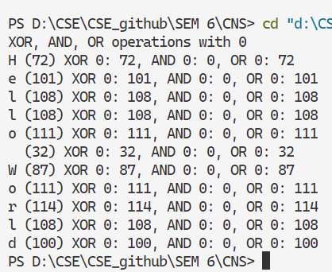**Output:**

**B. Write a C program that contains a string (char pointer) with a value 'Hello World’. The program should XOR, AND and OR each character in this string with 127 and displays the result.**

* **Code:**

#include <iostream>

#include <string>

using namespace std;

int main() {

string str = "Hello World";

int var_xor = 127, var_and = 127, var_or = 127;

cout << "XOR, AND, OR operations with 127" << endl;

for (int i = 0; i < str.length(); i++) {

cout << str[i] << " (" << int(str[i]) << ") ";

cout << "XOR " << var_xor << ": " << (str[i] ^ var_xor) << ", ";

cout << "AND " << var_and << ": " << (str[i] & var_and) << ", ";

cout << "OR " << var_or << ": " << (str[i] | var_or) << endl;

}

return0**;**

**}**

* 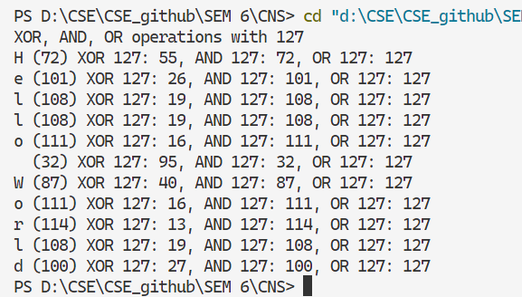**Output:**

**C. Write a C program that contains a string (char pointer) with a value 'Hello World’. The program should bitwise OR, left shift and right shift each character in this string and displays the result.**

* **Code:**

#include <iostream>

#include <string>

using namespace std;

int main() {

string str = "Hello World";

int var_or = 127;

cout << "Bitwise OR, Left Shift, and Right Shift operations" << endl;

for (int i = 0; i < str.length(); i++) {

cout << str[i] << " (" << int(str[i]) << ") ";

cout << "OR " << var_or << ": " << (str[i] | var_or) << ", ";

cout << "Left Shift 1: " << (str[i] << 1) << ", ";

cout << "Right Shift 1: " << (str[i] >> 1) << endl;

}

return 0;

}

* 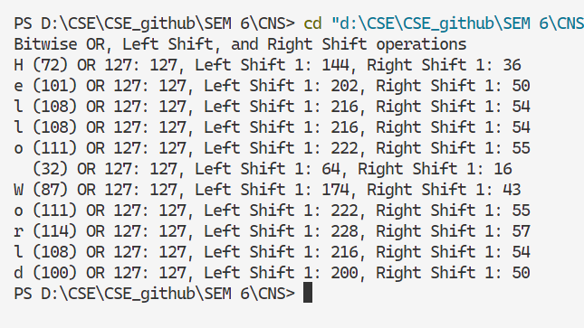**Output:**

# **Practical – 2**

**AIM: To implement Caesar Cipher Encryption - Decryption**

* **Code:**

**#include <iostream>**

**#include <string>**

**using namespace std;**

**string encryption(string str, int key) {**

**string encrypted_str = "";**

**for (int i = 0; i < str.length(); i++) {**

**char c = str.at(i);**

**if(c == ' ') {**

**} else {**

**if (isalpha(c)) {**

**if (islower(c)) {**

**c = (c - 'a' + key) % 26 + 'a';**

**} else if (isupper(c)) {**

**c = (c - 'A' + key) % 26 + 'A';**

**}**

**} else {**

**int temp = (int) c;**

**temp += key;**

**c = (char) temp;**

**}**

**}**

**encrypted_str += c;**

**}**

**return encrypted_str;**

**}**

**string description(string encrypted_str, int key) {**

**string str = "";**

**for (int i = 0; i < encrypted_str.length(); i++) {**

**char c = encrypted_str.at(i);**

**if(c == ' ') {**

**} else {**

**if (isalpha(c)) {**

**if (islower(c)) {**

**c = (c - 'a' - key + 26) % 26 + 'a';**

**} else if (isupper(c)) {**

**c = (c - 'A' - key + 26) % 26 + 'A';**

**}**

**} else {**

**int temp = (int) c;**

**temp -= key;**

**c = (char) temp;**

**}**

**}**

**str += c;**

**}**

**return str;**

**}**

**int main() {**

**string str = "hello world";**

**unsigned int key = 5;**

**cout << "Enter any text" << endl;**

**getline(cin, str);**

**cout << "Enter key" << endl;**

**cin >> key;**

**string encrypted_str = encryption(str, key);**

**string description_str = description(encrypted_str, key);**

**cout << "text: " << str << endl;**

**cout << "Encrypted text: " << encrypted_str << endl;**

**cout << "descripted text: " << description_str << endl;**

**return 0;**

**}**

* **Output:**

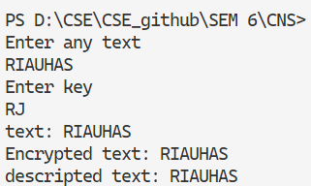

# **Practical – 3**

**AIM: To implement Mono-alphabetic Cipher Encryption – Decryption.**

* **Code:**

#include <iostream>

#include <string>

using namespace std;

string encrypt_text(string plaintext, string key) {

string normal = "ABCDEFGHIJKLMNOPQRSTUVWXYZ";

string ciphertext = "";

for (int i = 0; i < plaintext.length(); i++) {

char ch = plaintext[i];

if (ch >= 'A' && ch <= 'Z') {

int index = ch - 'A';

ciphertext += key[index];

}

else if (ch >= 'a' && ch <= 'z') {

int index = ch - 'a';

ciphertext += tolower(key[index]);

}

else {

ciphertext += ch;

}

}

return ciphertext;

}

string decrypt_cipher(string ciphertext, string key) {

string normal = "ABCDEFGHIJKLMNOPQRSTUVWXYZ";

string plaintext = "";

for (int i = 0; i < ciphertext.length(); i++) {

char ch = ciphertext[i];

if (ch >= 'A' && ch <= 'Z') {

int index = key.find(ch);

plaintext += normal[index];

}

else if (ch >= 'a' && ch <= 'z') {

int index = key.find(toupper(ch));

plaintext += tolower(normal[index]);

}

else {

plaintext += ch;

}

}

return plaintext;

}

int main() {

string key = "QWERTYUIOPLKJHGFDSAZXCVBNM";

string message;

cout << "Enter the message: ";

getline(cin, message);

string encryptedText = encrypt_text(message, key);

string decryptedText = decrypt_cipher(encryptedText, key);

cout << "Encrypted Text: " << encryptedText << endl;

cout << "Decrypted Text: " << decryptedText << endl;

return 0;

}

* 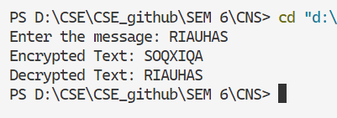**Output:**

# **Practical – 4**

**AIM: To implement Hill Cipher Encryption**

* Code:

#include <iostream>

#include <cstring>

using namespace std;

const int SIZE = 3;

void multiplyMatrix(int key[SIZE][SIZE], int text[SIZE], int result[SIZE]) {

for (int i = 0; i < SIZE; i++) {

result[i] = 0;

for (int j = 0; j < SIZE; j++) {

result[i] += key[i][j] * text[j];

}

result[i] = (result[i] % 26 + 26) % 26;

}

}

int modInverse(int a, int m) {

a = a % m;

for (int x = 1; x < m; x++) {

if ((a * x) % m == 1) {

return x;

}

}

return -1;

}

void findInverseMatrix(int key[SIZE][SIZE], int inverseKey[SIZE][SIZE]) {

int determinant = key[0][0] * (key[1][1] * key[2][2] - key[1][2] * key[2][1]) -

key[0][1] * (key[1][0] * key[2][2] - key[1][2] * key[2][0]) +

key[0][2] * (key[1][0] * key[2][1] - key[1][1] * key[2][0]);

determinant = (determinant % 26 + 26) % 26;

int determinantInverse = modInverse(determinant, 26);

if (determinantInverse == -1) {

cout << "Key matrix is not invertible.\n";

return;

}

int adjoint[SIZE][SIZE] = {

{(key[1][1] * key[2][2] - key[1][2] * key[2][1]), -(key[0][1] * key[2][2] - key[0][2] * key[2][1]), (key[0][1] * key[1][2] - key[0][2] * key[1][1])},

{-(key[1][0] * key[2][2] - key[1][2] * key[2][0]), (key[0][0] * key[2][2] - key[0][2] * key[2][0]), -(key[0][0] * key[1][2] - key[0][2] * key[1][0])},

{(key[1][0] * key[2][1] - key[1][1] * key[2][0]), -(key[0][0] * key[2][1] - key[0][1] * key[2][0]), (key[0][0] * key[1][1] - key[0][1] * key[1][0])}

};

for (int i = 0; i < SIZE; i++) {

for (int j = 0; j < SIZE; j++) {

inverseKey[i][j] = (adjoint[i][j] * determinantInverse) % 26;

if (inverseKey[i][j] < 0) {

inverseKey[i][j] += 26;

}

}

}

}

void encrypt_text(char plaintext[], char ciphertext[]) {

int key[SIZE][SIZE] = {{6, 24, 1}, {13, 16, 10}, {20, 17, 15}};

int textBlock[SIZE], encryptedBlock[SIZE];

int len = strlen(plaintext);

while (len % SIZE != 0) {

plaintext[len] = 'X';

len++;

plaintext[len] = '\0';

}

cout << "Encrypted Text: ";

for (int i = 0; i < len; i += SIZE) {

for (int j = 0; j < SIZE; j++) {

textBlock[j] = plaintext[i + j] - 'A';

}

multiplyMatrix(key, textBlock, encryptedBlock);

for (int j = 0; j < SIZE; j++) {

ciphertext[i + j] = (char)(encryptedBlock[j] + 'A');

cout << ciphertext[i + j];

}

}

ciphertext[len] = '\0'; // Null terminate the ciphertext

cout << endl;

}

void decrypt_cipher(char ciphertext[]) {

int key[SIZE][SIZE] = {{6, 24, 1}, {13, 16, 10}, {20, 17, 15}};

int inverseKey[SIZE][SIZE];

findInverseMatrix(key, inverseKey);

int textBlock[SIZE], decryptedBlock[SIZE];

int len = strlen(ciphertext);

cout << "Decrypted Text: ";

for (int i = 0; i < len; i += SIZE) {

for (int j = 0; j < SIZE; j++) {

textBlock[j] = ciphertext[i + j] - 'A';

}

multiplyMatrix(inverseKey, textBlock, decryptedBlock);

for (int j = 0; j < SIZE; j++) {

cout << (char)(decryptedBlock[j] + 'A');

}

}

cout << endl;

}

int main() {

char plaintext[100], ciphertext[100];

cout << "Enter plaintext (uppercase letters only): ";

cin >> plaintext;

encrypt_text(plaintext, ciphertext);

decrypt_cipher(ciphertext);

return 0;

}

* 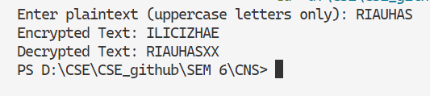Output:

# **Practical – 5**

**AIM: To implement Poly-alphabetic Cipher (Vigener Cipher) Technique**

* Code:

#include <iostream>

#include <cstring>

using namespace std;

void generateKey(const char* text, const char* key, char* newKey) {

int textLen = strlen(text), keyLen = strlen(key);

for (int i = 0, j = 0; i < textLen; i++, j++) {

if (j == keyLen) {

j = 0;

}

newKey[i] = key[j];

}

newKey[textLen] = '\0';

}

void encrypt_text(const char* text, const char* key, char* encryptedText) {

int len = strlen(text);

for (int i = 0; i < len; i++) {

encryptedText[i] = ((text[i] + key[i]) % 26) + 'A';

}

encryptedText[len] = '\0';

}

void decrypt_cipher(const char* encryptedText, const char* key, char* decryptedText) {

int len = strlen(encryptedText);

for (int i = 0; i < len; i++) {

decryptedText[i] = (((encryptedText[i] - key[i]) + 26) % 26) + 'A';

}

decryptedText[len] = '\0';

}

int main() {

char text[100], key[100], newKey[100], encryptedText[100], decryptedText[100];

cout << "Enter text (uppercase letters only): ";

cin >> text;

cout << "Enter key (uppercase letters only): ";

cin >> key;

generateKey(text, key, newKey);

encrypt_text(text, newKey, encryptedText);

decrypt_cipher(encryptedText, newKey, decryptedText);

cout << "Encrypted Text: " << encryptedText << endl;

cout << "Decrypted Text: " << decryptedText << endl;

return 0;

}

* 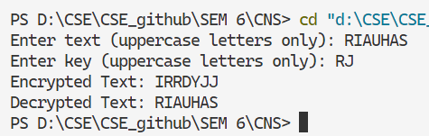Output:

# **Practical – 6**

**AIM: To implement Play-Fair Cipher Technique.**

* **Code:**

#include <iostream>

#include <string>

using namespace std;

const int SIZE = 5;

void generateKeyMatrix(const string& key, char keyMatrix[SIZE][SIZE]) {

bool used[26] = {false};

string refinedKey = "";

for (char ch : key) {

if (ch >= 'a' && ch <= 'z') ch -= 32;

if (ch == 'J') ch = 'I';

if (ch >= 'A' && ch <= 'Z' && !used[ch - 'A']) {

refinedKey += ch;

used[ch - 'A'] = true;

}

}

for (char ch = 'A'; ch <= 'Z'; ++ch) {

if (ch == 'J') continue;

if (!used[ch - 'A']) {

refinedKey += ch;

used[ch - 'A'] = true;

}

}

int index = 0;

for (int i = 0; i < SIZE; ++i) {

for (int j = 0; j < SIZE; ++j) {

keyMatrix[i][j] = refinedKey[index++];

}

}

}

void findPosition(char keyMatrix[SIZE][SIZE], char ch, int &row, int &col) {

if (ch == 'J') ch = 'I';

for (int i = 0; i < SIZE; ++i) {

for (int j = 0; j < SIZE; ++j) {

if (keyMatrix[i][j] == ch) {

row = i;

col = j;

return;

}

}

}

}

string prepareText(const string& text) {

string result = "";

for (char ch : text) {

if ((ch >= 'a' && ch <= 'z') || (ch >= 'A' && ch <= 'Z')) {

if (ch >= 'a' && ch <= 'z') ch -= 32;

result += ch;

}

}

string processed = "";

for (size_t i = 0; i < result.length(); ++i) {

processed += result[i];

if (i + 1 < result.length() && result[i] == result[i + 1]) {

processed += 'X';

}

}

if (processed.length() % 2 != 0) {

processed += 'X';

}

return processed;

}

string encrypt(const string& text, char keyMatrix[SIZE][SIZE]) {

string preparedText = prepareText(text);

string encryptedText = "";

for (size_t i = 0; i < preparedText.length(); i += 2) {

char first = preparedText[i];

char second = preparedText[i + 1];

int row1, col1, row2, col2;

findPosition(keyMatrix, first, row1, col1);

findPosition(keyMatrix, second, row2, col2);

if (row1 == row2) {

encryptedText += keyMatrix[row1][(col1 + 1) % SIZE];

encryptedText += keyMatrix[row2][(col2 + 1) % SIZE];

} else if (col1 == col2) {

encryptedText += keyMatrix[(row1 + 1) % SIZE][col1];

encryptedText += keyMatrix[(row2 + 1) % SIZE][col2];

} else {

encryptedText += keyMatrix[row1][col2];

encryptedText += keyMatrix[row2][col1];

}

}

return encryptedText;

}

string decrypt(const string& text, char keyMatrix[SIZE][SIZE]) {

string decryptedText = "";

for (size_t i = 0; i < text.length(); i += 2) {

char first = text[i];

char second = text[i + 1];

int row1, col1, row2, col2;

findPosition(keyMatrix, first, row1, col1);

findPosition(keyMatrix, second, row2, col2);

if (row1 == row2) {

decryptedText += keyMatrix[row1][(col1 - 1 + SIZE) % SIZE];

decryptedText += keyMatrix[row2][(col2 - 1 + SIZE) % SIZE];

} else if (col1 == col2) {

decryptedText += keyMatrix[(row1 - 1 + SIZE) % SIZE][col1];

decryptedText += keyMatrix[(row2 - 1 + SIZE) % SIZE][col2];

} else {

decryptedText += keyMatrix[row1][col2];

decryptedText += keyMatrix[row2][col1];

}

}

return decryptedText;

}

int main() {

string key, text;

char keyMatrix[SIZE][SIZE];

cout << "Enter key: ";

cin >> key;

generateKeyMatrix(key, keyMatrix);

cout << "Enter text to encrypt: ";

cin >> text;

string encryptedText = encrypt(text, keyMatrix);

cout << "Encrypted Text: " << encryptedText << endl;

string decryptedText = decrypt(encryptedText, keyMatrix);

cout << "Decrypted Text: " << decryptedText << endl;

return 0;

}

* 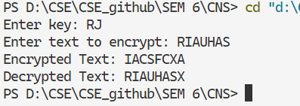**Output:**

# **Practical – 7**

**AIM: Write a program to implement Rail-Fence, Simple columnar Encryption Technique.**

* **Code:**

#include <iostream>

#include <cstring>

using namespace std;

string railFenceEncrypt(string text, int key) {

char rail[key][text.length()];

memset(rail, ' ', sizeof(rail));

int row = 0, direction = 1;

for (int i = 0; i < text.length(); i++) {

rail[row][i] = text[i];

row += direction;

if (row == key - 1 || row == 0) direction *= -1;

}

string encryptedText = "";

for (int i = 0; i < key; i++) {

for (int j = 0; j < text.length(); j++) {

if (rail[i][j] != ' ') encryptedText += rail[i][j];

}

}

return encryptedText;

}

string railFenceDecrypt(string cipher, int key) {

char rail[key][cipher.length()];

memset(rail, ' ', sizeof(rail));

int row = 0, direction = 1;

for (int i = 0; i < cipher.length(); i++) {

rail[row][i] = '*';

row += direction;

if (row == key - 1 || row == 0) direction *= -1;

}

int index = 0;

for (int i = 0; i < key; i++) {

for (int j = 0; j < cipher.length(); j++) {

if (rail[i][j] == '*' && index < cipher.length()) {

rail[i][j] = cipher[index++];

}

}

}

string decryptedText = "";

row = 0, direction = 1;

for (int i = 0; i < cipher.length(); i++) {

decryptedText += rail[row][i];

row += direction;

if (row == key - 1 || row == 0) direction *= -1;

}

return decryptedText;

}

void sortKey(string key, int keyOrder[]) {

int len = key.length();

char tempKey[len];

for (int i = 0; i < len; i++) tempKey[i] = key[i];

for (int i = 0; i < len; i++) {

int minIdx = i;

for (int j = i + 1; j < len; j++) {

if (tempKey[j] < tempKey[minIdx]) {

minIdx = j;

}

}

swap(tempKey[i], tempKey[minIdx]);

swap(keyOrder[i], keyOrder[minIdx]);

}

}

string columnarEncrypt(string text, string key) {

int keyLen = key.length();

int textLen = text.length();

int numRows = (textLen + keyLen - 1) / keyLen;

char grid[numRows][keyLen];

int index = 0;

for (int i = 0; i < numRows; i++) {

for (int j = 0; j < keyLen; j++) {

grid[i][j] = (index < textLen) ? text[index++] : 'X';

}

}

int keyOrder[keyLen];

for (int i = 0; i < keyLen; i++) keyOrder[i] = i;

sortKey(key, keyOrder);

string encryptedText = "";

for (int i = 0; i < keyLen; i++) {

int col = keyOrder[i];

for (int j = 0; j < numRows; j++) {

encryptedText += grid[j][col];

}

}

return encryptedText;

}

string columnarDecrypt(string cipher, string key) {

int keyLen = key.length();

int cipherLen = cipher.length();

int numRows = (cipherLen + keyLen - 1) / keyLen;

char grid[numRows][keyLen];

int keyOrder[keyLen];

for (int i = 0; i < keyLen; i++) keyOrder[i] = i;

sortKey(key, keyOrder);

int index = 0;

for (int i = 0; i < keyLen; i++) {

int col = keyOrder[i];

for (int j = 0; j < numRows; j++) {

grid[j][col] = cipher[index++];

}

}

string decryptedText = "";

for (int i = 0; i < numRows; i++) {

for (int j = 0; j < keyLen; j++) {

decryptedText += grid[i][j];

}

}

return decryptedText;

}

int main() {

string text, key;

int railKey;

cout << "Enter text to encrypt: ";

cin >> text;

cout << "Enter Rail-Fence key: ";

cin >> railKey;

string railCipher = railFenceEncrypt(text, railKey);

cout << "Rail-Fence Encrypted Text: " << railCipher << endl;

string railDecrypted = railFenceDecrypt(railCipher, railKey);

cout << "Rail-Fence Decrypted Text: " << railDecrypted << endl;

cout << "Enter Columnar Transposition key (word): ";

cin >> key;

string columnCipher = columnarEncrypt(text, key);

cout << "Columnar Encrypted Text: " << columnCipher << endl;

string columnDecrypted = columnarDecrypt(columnCipher, key);

cout << "Columnar Decrypted Text: " << columnDecrypted << endl;

return 0;

}

* 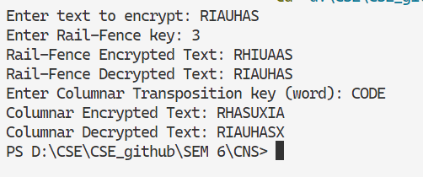**Output:**

# **Practical – 8**

**AIM: To implement the S-DES algorithm for data encryption.**

* **Code:**

#include <iostream>

#include <string>

using namespace std;

int P10[] = {3, 5, 2, 7, 4, 10, 1, 9, 8, 6};

int P8[] = {6, 3, 7, 4, 8, 5, 10, 9};

int IP[] = {2, 6, 3, 1, 4, 8, 5, 7};

int IP_inv[] = {4, 1, 3, 5, 7, 2, 8, 6};

int EP[] = {4, 1, 2, 3, 2, 3, 4, 1};

int P4[] = {2, 4, 3, 1};

int S0[4][4] = {

{1, 0, 3, 2}, {3, 2, 1, 0}, {0, 2, 1, 3}, {3, 1, 3, 2}};

int S1[4][4] = {

{0, 1, 2, 3}, {2, 0, 1, 3}, {3, 0, 1, 0}, {2, 1, 0, 3}};

string permute(string input, int* table, int size) {

string output = "";

for (int i = 0; i < size; i++) {

output += input[table[i] - 1];

}

return output;

}

string leftShift(string key, int shifts) {

return key.substr(shifts) + key.substr(0, shifts);

}

string generateKey(string key, bool first) {

key = permute(key, P10, 10);

key = leftShift(key.substr(0, 5), first ? 1 : 2) + leftShift(key.substr(5, 5), first ? 1 : 2);

return permute(key, P8, 8);

}

string xorOperation(string a, string b) {

string result = "";

for (size_t i = 0; i < a.length(); i++) {

result += (a[i] == b[i]) ? '0' : '1';

}

return result;

}

string sBox(string input, int S[4][4]) {

int row = (input[0] - '0') * 2 + (input[3] - '0');

int col = (input[1] - '0') * 2 + (input[2] - '0');

int val = S[row][col];

return string(1, '0' + (val / 2)) + string(1, '0' + (val % 2));

}

string fk(string input, string key) {

string left = input.substr(0, 4);

string right = input.substr(4, 4);

string expandedRight = permute(right, EP, 8);

string xored = xorOperation(expandedRight, key);

string sboxOut = sBox(xored.substr(0, 4), S0) + sBox(xored.substr(4, 4), S1);

string permuted = permute(sboxOut, P4, 4);

return xorOperation(left, permuted) + right;

}

string swapHalves(string input) {

return input.substr(4, 4) + input.substr(0, 4);

}

string encrypt(string plaintext, string key) {

string K1 = generateKey(key, true);

string K2 = generateKey(key, false);

string permutedText = permute(plaintext, IP, 8);

string firstRound = fk(permutedText, K1);

string swapped = swapHalves(firstRound);

string secondRound = fk(swapped, K2);

return permute(secondRound, IP_inv, 8);

}

string decrypt(string ciphertext, string key) {

string K1 = generateKey(key, true);

string K2 = generateKey(key, false);

string permutedText = permute(ciphertext, IP, 8);

string firstRound = fk(permutedText, K2);

string swapped = swapHalves(firstRound);

string secondRound = fk(swapped, K1);

return permute(secondRound, IP_inv, 8);

}

int main() {

string key, plaintext;

cout << "Enter 10-bit key: ";

cin >> key;

cout << "Enter 8-bit plaintext: ";

cin >> plaintext;

string ciphertext = encrypt(plaintext, key);

cout << "Encrypted Text: " << ciphertext << endl;

string decryptedText = decrypt(ciphertext, key);

cout << "Decrypted Text: " << decryptedText << endl;

return 0;

}

* 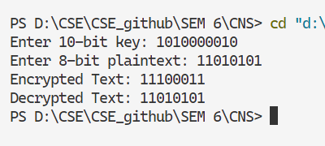**Output:**

# **Practical – 9**

**AIM: Write a program to implement RSA asymmetric (public key and private key) -Encryption**

* **Code:**

#include <iostream>

#include <string>

#include <cmath>

using namespace std;

long long modExp(long long base, long long exp, long long mod) {

long long result = 1;

base = base % mod;

while (exp > 0) {

if (exp % 2 == 1) {

result = (result * base) % mod;

}

exp = exp >> 1;

base = (base * base) % mod;

}

return result;

}

long long simpleHash(const string& message, long long n) {

long long hash = 0;

for (char c : message) {

hash = (hash * 31 + c) % n;

}

return hash;

}

long long gcdExtended(long long a, long long b, long long* x, long long* y) {

if (a == 0) {

*x = 0;

*y = 1;

return b;

}

long long x1, y1;

long long gcd = gcdExtended(b % a, a, &x1, &y1);

*x = y1 - (b / a) * x1;

*y = x1;

return gcd;

}

long long modInverse(long long e, long long phi) {

long long x, y;

long long g = gcdExtended(e, phi, &x, &y);

if (g != 1) {

cerr << "Modular inverse doesn't exist";

exit(EXIT_FAILURE);

}

return (x % phi + phi) % phi;

}

void generateKeys(long long& e, long long& d, long long& n) {

long long p = 1009;

long long q = 1013;

n = p * q;

long long phi = (p - 1) * (q - 1);

e = 65537;

d = modInverse(e, phi);

}

long long signMessage(long long hash, long long d, long long n) {

return modExp(hash, d, n);

}

bool verifySignature(long long hash, long long signature, long long e, long long n) {

long long decryptedHash = modExp(signature, e, n);

return hash == decryptedHash;

}

int main() {

string message;

cout << "Enter message: ";

getline(cin, message);

long long e, d, n;

generateKeys(e, d, n);

long long hashValue = simpleHash(message, n);

long long signature = signMessage(hashValue, d, n);

cout << "Original Hash: " << hashValue << endl;

cout << "Signature: " << signature << endl;

if (verifySignature(hashValue, signature, e, n)) {

cout << "Signature verified successfully!" << endl;

} else {

cout << "Signature verification failed!" << endl;

}

return 0;

}

* 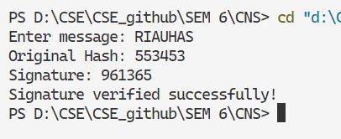**Output:**